

|  |
| --- |
| JOB ROLE PROFILE AND PERSON SPECIFICATION |

Post Title and Number: Head of Exchequer Services______

Present Grade: HOS 2 Dept: Resources___________________

Service/Section/Team: Exchequer Services ______________________________________

Reports to (title): Director of Corporate Finance___________________________________

|  |
| --- |
| Purpose of the Role: |

1. **PURPOSE OF YOUR JOB**
   1. To deliver a high quality, responsive, effective, and timely Finance Service which includes the management of the Payroll Service, the Councils Accounts Payable, Accounts Receivable, Purchasing and Direct Payments Service as well as Payments and Revenue Services.
   2. Customer facing, this role will provide a scrutiny and challenge role in relation to all exchequer and finance related issues and will work closely and proactively with members and senior managers, understanding and clarifying their finance requirements to deliver a professional high quality and responsive service that promotes efficient and effective service delivery in line with the Council’s objectives and priorities.
   3. To play a key role in the development of the Council wide strategies, providing financial and technical advice; managing the delivery of corporate and directorate finance priorities; anticipating risks and issues and proactively addressing barriers to progress; the provision of a finance service which meets the requirements of all customers over the whole range of financial resource management activities.
   4. To provide a trading service to customers, including negotiating service level agreements, monitoring, and reporting on performance of the service.
   5. To drive and support the continuous improvement and development of the Exchequer Service ensuring statutory compliance and the provision of excellent customer service.
   6. To lead on/contribute toward major projects within the Council and with partner agencies and assess and report on the financial implications of all new projects, policies, and service developments in the context of corporate priorities and value for money.
   7. To consider opportunities for the most efficient and effective way in which the service, under the postholder’s remit, is delivered including marketing the service to other organisations with the aim of income generation for the service on a cost-effective basis.
   8. The role will be responsible for the day-to-day management and continuous improvement, development and professionalism of the staff delivering the finance service.
   9. The post holder will be the Council’s lead exchequer finance expert and will be required to make critical decisions, if necessary, without reference to a senior post holder. Decisions taken may have a critical effect on:

- The financial stability of the Council

- The integrity of the Council’s finance processes

- The achievement of value for money

- The nature and quality of service delivery

- The Council’s use of resources

- The Council’s reputation

* 1. Creativity and innovation will be essential to this role. The post holder will be required to advise on several diverse business and finance related subjects at a senior level. The post holder will be expected to apply a range of financial expertise where the frequent opportunity and need for imaginative thinking is not limited by defined policies (for example, the provision of expert financial and legislative knowledge and direction for service wide initiatives) and will be expected to shape and influence policy development.

|  |
| --- |
| Dimensions including Structure Chart: |

* 1. **Annual budgetary amounts with which the role is either directly or indirectly concerned:**
  + Payroll Gross Pay - £358m
  + Statutory PAYE Contributions - £101m
  + LGPS Contributions - £47m
  + Teachers’ Pension Contribution £34m
  + Commercial AP payments - £349m
  + Non-Commercial Payments - £691m
  + Collection of Sundry Debt - £94k
  + Income collection and reconciliation - £636m
  + Exchequer Service income generation - £915k
  1. **Structure Chart:**

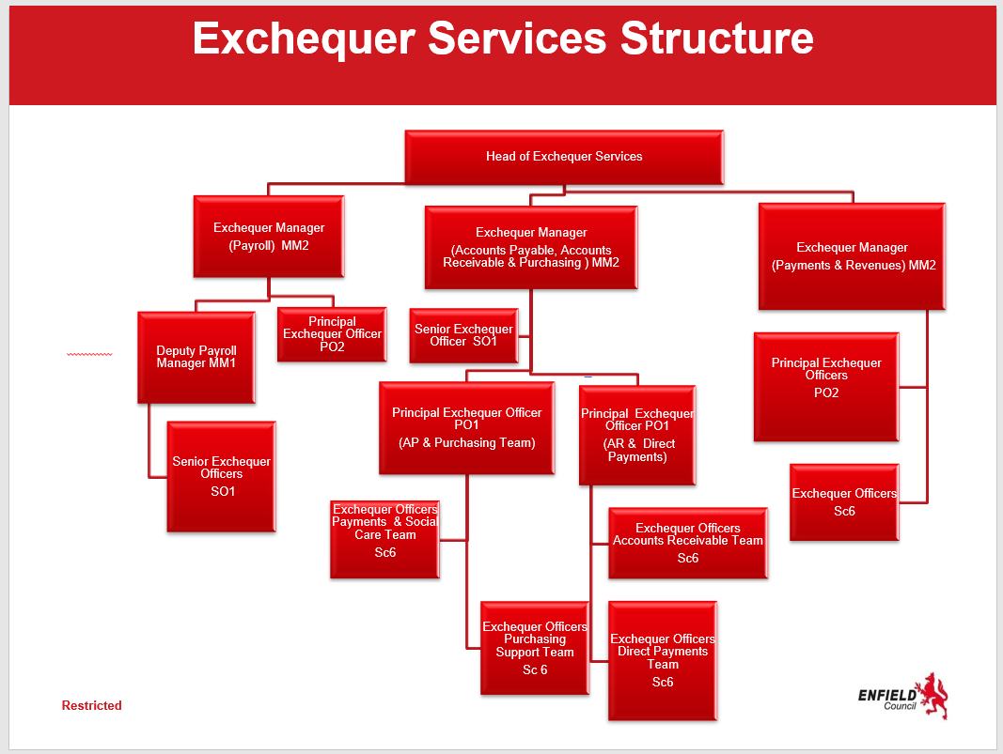

Number of direct reports: 3

Number of subordinate staff: 40

**2.3 Nature of reporting relationship between post holder and line manager**

2.3.1 To be responsible for all aspects of the payroll service, accounts payable, account receivable, purchasing, direct payments and payments and revenues. The provision of a high-quality financial management support service to departments and to assist the post holder in the discharge of the Executive Director of Resources’ statutory financial responsibilities within the Council.

2.3.2 To act in a deputising role in the absence of the Director of Corporate Finance

2.3.3 To provide high quality financial advice to the Chief Executive, Director, Departmental Management Teams, and Service Managers on all financial matters relating to the Departments.

2.3.4 Working with colleagues, to pay a key role in the development of Council wide financial strategies and procedures and to contribute to the continuous improvement of the Council’s overall financial administration, management, and performance.

2.3.5 To give advice and report on the financial implications of new projects, policies and service developments as required in the context of corporate priorities and financial resources

2.3.6 To promote and ensure the adoption and adherence to agreed financial processes throughout the Departments.

2.3.7 To contribute to the corporate delivery of the Council’s vision and values, providing a clear sense of direction and purpose.

2.3.8 Expected to identify innovative solutions to difficult financial problems and to work unsupervised on a wide range of complex financial and service delivery issues requiring lateral thinking and analytical skills.

2.3.9 Responsible for the leadership and line management of staff.

2.3.10 To be responsible for the recruitment, induction, appraisal, assessment of training needs (including that these are met in the most appropriate and effective ways and evaluated) and where necessary capability and disciplinary issues for all staff within the unit managed. To direct, manage, guide and appraise staff and ensure that they have the necessary skills and knowledge to undertake their roles with maximum effect.

|  |
| --- |
| Key Accountabilities: |

|  |
| --- |
| **Strategic** |
| To support the delivery of the organization’s vision, corporate and service plan objectives through the provision of financial advice to Members, Directors, and Management Teams. |
| To influence the strategic decision-making process to ensure that it properly reflects and acknowledges financial issues and practices and bring forward innovative recommendations for the ongoing improvements in the exchequer service. |
| To advice and support service management teams and the relevant politicians on the organization’s financial strategies and policies and their impact both generally and in individual service portfolio areas |
| To contribute to the development of financial plans and investment strategies to support the achievement of service plans and objectives, be the Council expert on all exchequer related matters. |
| To assess the changing needs and demands of the organisation in the medium and longer term for financial resources in relation to achieving service policy, plans, and objectives. |
| To provide a finance service, which meets the requirements of all customers over the whole range of financial resource management activities and assists the Executive Director of Resources in discharging his/her S151 responsibilities in accordance with professional standards. |
| Leadership/Service Provision |
| To contribute to the management and leadership of the finance service, through support to senior managers by representing them on project teams and boards and through deputising for them where necessary on relevant matters to ensure effective discharge of statutory and professional duties. |
| To apply a range of financial expertise where the frequent opportunity and need for imaginative thinking is not limited by defined policies and practices and bring forward innovative recommendations for the ongoing improvements in financial management |
| To provide services in accordance with professional standards and a robust financial control framework, which meets the requirements of all customers over the whole range of financial management activities including regular attendance at Senior Management Groups. |
| To be the Council's expert financial adviser on exchequer related services ensuring compliance with all statutory and professional accounting codes and meeting all external financial reporting requirements and to manage the Council’s relationship with its external stakeholders. |
| Providing corporate advice, guidance, training and offering recommendations on all aspects of the exchequer service e.g PAYE legislation and employer statutory obligations. Lead/contribute to the review of processes to ensure compliance with the relevant statutory regulations to minimise the risk of fines and penalties. |
| Manage, direct and co-ordinate the reconciliation of the accounts and all returns relating to all exchequer services in accordance with statutory and corporate timetables and professional standards. |
| Provide financial advice, financial modelling, business analysis, options appraisals, unit cost development and analysis, external risk assessment and performance benchmarking to management teams to ensure fact based robust decision making underpinned by sound financial appraisal and to influence the prioritisation of programmes of work. |
| To ensure all financial developments are reflected in the Council’s procedures and that any training and development required to achieve this takes place and to secure continuous improvement in the Council’s systems and procedures. |
| Provide a regular overview of current and projected financial performance for the service, identifying current and anticipated key issues and hotspots supported by solutions and proposals to address current and anticipated concerns through early intervention and timely management action to ensure that risks are minimised and performance optimised. |
| To lead on/contribute toward major projects within the Council and with partner agencies and assess and report on the financial implications of all new projects, policies, and service developments in the context of corporate priorities and value for money. |
| Contribute to the development of a corporate-wide approach to financial systems, data, and information management in order to ensure that both corporate and service-driven requirements and standards are incorporated. |
| To represent the organisation’s interests with key stakeholders, in government, and other appropriate bodies to ensure that the organisation’s interests and resources are optimized (depending on the nature of expertise required, this may require the holder to work outside their immediate service portfolio area). |
| To ensure that the necessary leadership, motivation, and development of the performance of staff is achieved to enable the organisation to attract and retain expert capability in finance and provide a cost-effective service. |
| To ensure that the resources allocated to the service are deployed and controlled efficiently to achieve the organisation’s corporate objectives and achieve value for money. |
| **Service Development** |
| To consider opportunities for the most efficient and effective way in which the service under the post holders’ remit is delivered. |
| To review financial management information/processes and standardized processes |
| To consider alternative service delivery models |
| To actively market the service with a view of offering accountancy and financial services to public sector and similar bodies on an agency, joint venture, or partnership basis with the aim of income generation for the service on a cost-effective basis. To give presentations, undertake promotions, produce information, prepare service level agreements, make proposals and lead on negotiations to secure this. |
| **Knowledge** |
| Extensive knowledge and application of local government finance and a thorough understanding of relevant financial legislation, professional codes, and financial best practice in relation to transactions service e.g. Employment Law and HMRC PAYE legislation. |
| **Experience** |
| Evidence of successful strategic and resource management in a large complex organisation, evaluating competing financial pressures within tight financial limits and demanding service strategies. |
| Lead and develop people through a wide range of managerial relationships to create a positive attitude to achieve objectives and overcome barriers to progress. |
| A record of managing and delivering change in a large complex organisation. |
| Successful track record of being responsible for delivering valued, sound financial advice to decision-makers. |
| Planning and reviewing the delivery of services and projects. |
| Successful track record and background of consistent achievement as a senior finance manager in a large, complex organisation, exploiting new opportunities, leading & managing change and achieving outcome related improvements. |
| Successful track record of communicating to and negotiating effectively with a wide range of audiences, internally and with external partners, to achieve corporate objectives. |
| A successful track record of working in partnership with a wide range of internal and external stakeholders to deliver corporate and service objectives. |
| A successful track record of effective project management, including the development, implementation and delivery of clear outcomes that deliver service and corporate objectives. |
| **SKILLS AND ABILITIES** |
| Demonstration of a commitment to achieving equality of opportunity in employment and service delivery. |
| Well-developed written and oral communications skills and the ability to communicate complex matters effectively to a broad range of people. |
| Strong awareness of and the ability to operate with sensitivity in the context of a political environment. Can also balance the competing pressures of corporate and service-led priorities and pressures to maximise the effectiveness of the organisation’s outcomes. |
| Can demonstrate the achievement of challenging and relevant performance measures including the ability to develop such measures to aid service improvement and performance. |
| **PERSONAL STYLE AND BEHAVIOUR** |
| Shows a resilience and toughness under pressure yet is sensitive to and shows awareness towards the needs of customers and clients. |
| Can demonstrate strong interpersonal and networking styles and has a high drive for achievement. |

|  |
| --- |
| Key Relationships (Internal and External): |

Relationships may involve the resolution of high-level contentious or complex matters that will require persuasion and negotiation with senior members of staff. The post holder will work in a responsive and proactive manner considering service wide pressures and needs, whilst identifying opportunities for improved efficiencies.

The post holder will be required to liaise with various teams and services Key contacts are likely to include:

- Politicians and Committees

- Chief Executive

- Executive Directors and Directors

- Service Management Teams and Heads of Service

- Government Departments and other statutory bodies

- Local Government Employers Association

- Employers Organisations

- Council suppliers, stakeholder employers and all council employees

The post holder will be required to establish and maintain functional working relationships with these contacts; building trust and rapport; and be expected to influence decision makers leading and developing financial policy and influencing the financial direction of the Council.

|  |
| --- |
| Equality and Diversity: |

The Council has a strong commitment to achieving equality in its service to the community and the employment of people and expects all employees to understand, comply with and promote its policies in their own work.

|  |
| --- |
| Health and Safety: |

The post holder shall ensure that the duties of the post are undertaken with due regard to the Council’s Health and Safety Policy and to their personal responsibilities under the provisions of the Health and Safety at work Act 1974 and all other relevant subordinate legislation.

For a more detailed definition of these responsibilities, refer to the current versions of the Corporate Health& Safety Policy, Group Safety Policy and employee information leaflet entitled "Health & Safety Policy; Guidance on Staff Health & Safety Responsibilities".

#### Corporate Health and Safety Responsibilities

All employees have personal responsibilities to take reasonable care for the health and safety of themselves and others. This means:

1. Understanding the hazards in the work they undertake.

2. Following safety rules and procedures.

3. Using work equipment, personal protective equipment, substances, and safety devices correctly; and

4. Working in accordance with the training provided and only undertaking tasks where appropriate training has been received.

Employees shall co-operate with the Council by allowing it to comply with its duties towards them. This requires employees to:

* take part in safety training and risk assessments and suggest ways of reducing risks; and
* take part in emergency evacuation exercises.

Employees shall report all accidents, ‘near miss’ incidents and work-related ill health conditions to their manager/supervisor/team leader.

Employees shall read the Corporate Health & Safety – Organisation Part B Policy to ascertain and understand their responsibilities as an employee, line manager, Assistant Director, or Director of the Council.

|  |
| --- |
| Information Security: |

To protect the confidentiality, integrity, and availability of Council information, including information provided by customers, partner organisations, and other third parties, where applicable, employees will comply with the Council’s Information Security Policy.

|  |
| --- |
| Other duties & responsibilities: |

This Job Role Profile is not to be regarded as exclusive or exhaustive. There will be other duties and requirements associated with your post and in addition, as a term of your employment, you may be required to undertake various other duties as may be reasonably required of you. This includes making yourself available to participate in a range of corporate initiatives as determined by your Line Manager. These could include activities such as participation in the Civil Emergencies Planning Rota, supporting the Scrutiny function, actively leading/participating in a range of cross-functioning review, and working groups.

|  |
| --- |
| Statement of Commitment to Safeguarding of Children and Vulnerable Adults through safer employment practice: |

Enfield Council is committed to safeguarding and promoting the welfare of children and vulnerable adults. Safe recruitment of staff is central to this commitment, and the Council will ensure that its recruitment policies and practices are robust, and that selection procedures prevent unsuitable people from gaining access to children, young people and vulnerable adults. All staff employed to work with or on behalf of children and young people in the Council must be competent.

All staff working with Children & Vulnerable Adults should be aware of and share the commitment to safeguarding and promoting the welfare of children, young people and vulnerable adults when applying for posts at Enfield Council.

|  |
| --- |
| PERSON SPECIFICATION |

**Job Title: Head of Exchequer Services**  **Grade: HOS2**

**Department: Resources Team: Exchequer Services**

|  |  |
| --- | --- |
|  | **HOW TESTED**  Application – A  Test – T  Interview – I |
| **Job Specifics – Skills, Experience, Knowledge & Abilities**  **Essential:**   1. **Proven experience to lead, engage, motivate, appraise, and develop staff to deliver high standards of service and performance** 2. **Successfully lead teams to respond positively to change** 3. **Experience of effective budget management and delivery of services plans on time and on budget** 4. **A good understanding of the political structure and role of elected members** 5. **Successful strategic and resource management experience in a large financial and complex organisation with demanding pressures and deadlines.** 6. **Successful track record and background of consistent achievement as a senior manager overseeing finance processes and controls in a large, complex organisation, exploiting new opportunities, leading, and managing change and achieving improvements** 7. **Excellent written and oral communications skills and ability to articulate complex information to a broad range of people including report writing** 8. **Strong finance systems experience and knowledge relating to the service areas provided** 9. **Excellent understanding of financial controls and knowledge of HMRC requirements relating to the service.**   **Desirable:**  **1. SAP Systems experience** | **A/I**  **A/I** |
| **Behaviours**  Appropriate behaviours are key to the delivery of our vision for Enfield.  We want staff who will work collaboratively, flexibly and constructively, and exhibit this ethos in all their dealings with residents, colleagues and partners. Our leaders will be exemplars of the following behaviours and encourage them in staff at all levels;  **Take Responsibility**  We want staff who are willing to make decisions and be accountable for them. Staff should have a positive can-do attitude where they see problems as challenges which can be overcome. They should accept responsibility for service delivery, be clear about their service offer and deliver what they promise.  **Open, Honest and Respectful**  We want staff who are comfortable and confident to acknowledge the difficulties and the barriers they face. They should also be able to constructively challenge the way things are done where there is evidence that it impedes service delivery. Challenge should be conducted in a professional, courteous manner with the aim of reaching a mutually agreeable resolution.  **Listen and Learn**  We want staff who are prepared to actively listen and reflect on customer concerns with a view to understanding the customer’s point of view. Staff should be able to receive constructive criticism and be prepared to adapt the way they operate and deliver services where appropriate.  **Work Together to find solutions**  We want staff who can work collaboratively with other departments and partners, freely sharing their knowledge and skills to identify solutions to address customer concerns.  **Candidates: Please ensure you address these behaviours in your responses to the essential (and desirable if applicable) criteria above.** | **A/I** |
| **Competencies:**  **Candidates: Please ensure you address these competencies in your responses to the essential (and desirable if applicable) criteria above.**  **1.** Customer focus  **2.** Deliver service performance  **3.** Focus on continuous improvement  **4.** Political awareness and context | **A/I** |
| **Qualifications & Professional registration criteria**  **Candidates: Please ensure you address these qualifications in your responses to the essential (and desirable if applicable) criteria, you will be expected to meet these requirements of the role and they will be explored with you at interview.**  **1.**  **2.** | **I** |
| **Special requirements**  **Candidates: Please note you will be expected to meet these requirements of the role and they will be explored with you at interview.**  **1.**  **2.**  **3.** | **I** |