|  |
| --- |
| JOB ROLE PROFILE AND PERSON SPECIFICATION |

Post Title and Number: Insight Officer Present Grade: PO2

Dept: People

Service/Section/Team: Data & Intelligence

Reports to (title): Business Partner

|  |
| --- |
| Purpose of the Role: |

Produce analysis, statistical insights and drill downs and data extracts in a range of formats and solutions that allow the organisation to direct resources, understand trends, gain an understanding about residents and customers, take proactive and remedial action to improve performance and fulfil reporting requirements.

* Working with autonomy produce detailed and thorough intelligence for the People department: This will be through variety of means from Monthly statistical trackers to more in-depth analysis and reports in Power BI, Word, Excel, PowerPoint highlighting key trends and findings from raw data, reporting these findings and being accountable at People DMT, departments across London Borough of Enfield (LBE), North Central ICB, Key Strategic boards and briefings.
* Proactively look at current BI solutions to offer insight to services that allow them to become more efficient and effective and to understand patterns of demand
* Analyse trends in Commonly asked for topics and then proactively produce reports (Raw data and summarised) that can be published to reduce FOI, MEQ, Complaints
* Manipulate and Interpret data sets to prepare responses to FOI requests
* Research, Analyse and Interpret internal and external datasets to provide responses to requests from services in in a responsive and timely manner.
* Gather Extensive skills and knowledge across the department and wider Council Services to understand the key insights and measures needed for services to improve their delivery and outcomes.
* Develop the use of predictive analytics and data modelling to better inform service decisions and to allow services and departments to understand and predict future patterns of demand
* Work with the Business Partners to deliver Insight and Analytics as detailed in the annual work programme
* Undertake Quantitative and Qualitative Research using a range of techniques to understand and learn from best practice externally
* Extract data and develop reports in Management Information Systems to obtain data needed for research and analysis
* Use a range of software including Power BI, Business Objects, SQL, GIS and reporting and performance solutions to pull together reports and insights
* Provide and deliver regular and ad-hoc briefing notes to a range of audiences including senior officers and members at a range of forums and meetings
* Support the production of Business-Critical Data sets where these are not automated by systems and where appropriate analyse, combine and join datasets together to produce these key data items which can have legislative and budgetary implications.
* Analyse, interpreting and present information to internal and external audiences.
* Obtain, analyse and regularly report on performance using information obtained via central government and local sources, utilising benchmarking data where suitable
* Work in partnership with the business partners in Data & Intelligence team to support the production of the work outlined in the quarterly work programme
* Lead insight reports generation for children social care, education, adult social care and joint strategic needs assessments in public health.
* Support Inspections and audits through providing ongoing detailed analysis and reports to help services plan for inspections including, but not limited to, Ofsted which will have reputational impact for the Council.
* Support the Equalities agenda, providing robust support and advice throughout the organisation.
* Produce and then Present these report findings at SLT, People DMT and other Strategic Meetings as required.

|  |
| --- |
| Dimensions including Structure Chart: |

1. Annual budgetary amounts with which the role is either directly or indirectly concerned:

None

1. Structure Chart:

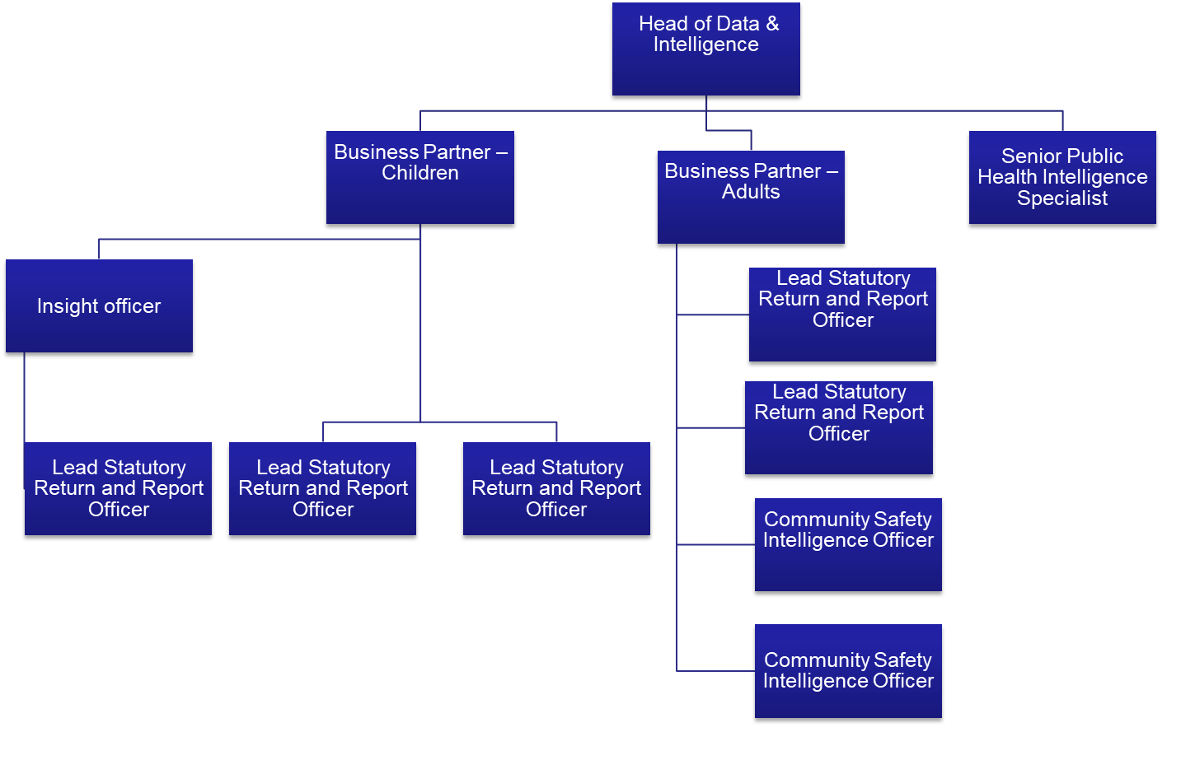

1. Number of direct reports:

One Lead Statutory Returns and Report Officer will report to Insight officer.

1. Nature of reporting relationship between post holder and line manager

Insight Officer will report to Children business as their line manager. However, Insight officer will work collaboratively across Business Partner-Adults and Senior Public Health Intelligence Specialist in order to produce insight reports for all teams across Data & Intelligence. As the role involves completing activities across all People department close liaison will also occur with the Business Partners for where activity resides.

|  |
| --- |
| Key Accountabilities: |

Insert the most important and frequent accountabilities first.

(You are not restricted to eight accountabilities)

|  |  |
| --- | --- |
| **Accountabilities** | **Anticipated level of time**  **H = High**  **M = Medium**  **L = low** |
| 1. Deliver robust analysis that allows Services and Directorates to make plans and take decisions based on strong intelligence and evidence 2. To support services and Directorates in proactively solving problems affecting the   quality of outcomes to residents and communities   1. Extract, Report, Research, collate and produce evidence and datasets to support this planning and decision making within services. 2. Lead on the production of business-critical datasets and reports where indepth analysis and modelling is required 3. Research and identify external and internal   datasets such as population and deprivation data required to help the Council understand demand for services now and in the future and develop predictive models   1. Prepare cyclical and ad-hoc reports, insight for senior management, members, the public, regulators and other external stakeholders. This will include sourcing data from a range of systems to ensure efficient and accurate reporting and supporting inspections 2. Undertake research using a range of techniques 3. Present findings to a range of audiences including senior officers and members 4. Use a range of reporting software solutions to develop understanding and extract data to inform analysis 5. Develop the use of Mapping within GIS and Power BI 6. Create a visible data resource in power BI that shows population, deprivation and other key datasets that the organisation can use proactively | H  H  H  H  H  H  H  M  M  M  M |
| 1. Any other duties reasonably requested by management | M |
| 1. Carry out all accountabilities in compliance with the Council’s Policies and Procedures |  |

|  |
| --- |
| Key Relationships (Internal and External): |

Internal

Build and maintain effective relationships with colleagues and senior officers across the organisation to develop insight and analytics, this will include attendance at meetings, boards and meetings with members and senior officers. This will include presentations with Senior officers at Executive Director, Director and Heads of Service.

External

Build and maintain effective relationships with other Local Authorities, Police, Health and CCG, Central government departments and where appropriate Support providers for systems

|  |
| --- |
| Equality and Diversity: |

The Council has a strong commitment to achieving equality in its service to the community and the employment of people and expects all employees to understand, comply with and promote its policies in their own work.

|  |
| --- |
| Health and Safety: |

The post holder shall ensure that the duties of the post are undertaken with due regard to the Council’s Health and Safety Policy and to their personal responsibilities under the provisions of the Health and Safety at work Act 1974 and all other relevant subordinate legislation.

For a more detailed definition of these responsibilities, refer to the current versions of the Corporate Health& Safety Policy, Group Safety Policy and employee information leaflet entitled "Health & Safety Policy; Guidance on Staff Health & Safety Responsibilities".

#### Corporate Health and Safety Responsibilities

All employees have personal responsibilities to take reasonable care for the health and safety of themselves and others. This means:

1. Understanding the hazards in the work they undertake;

2. Following safety rules and procedures;

3. Using work equipment, personal protective equipment, substances, and safety devices correctly; and

4. Working in accordance with the training provided and only undertaking tasks where appropriate training has been received.

Employees shall co-operate with the Council by allowing it to comply with its duties towards them. This requires employees to:

* take part in safety training and risk assessments and suggest ways of reducing risks; and
* take part in emergency evacuation exercises.

Employees shall report all accidents, ‘near miss’ incidents and work related ill health conditions to their manager/supervisor/team leader.

Employees shall read the Corporate Health & Safety – Organisation Part B Policy to ascertain and understand their responsibilities as an employee, line manager, Assistant Director or Director of the Council.

|  |
| --- |
| Information Security: |

To protect the confidentiality, integrity and availability of Council information, including information provided by customers, partner organisations, and other third parties, where applicable, employees will comply with the Council’s Information Security Policy.

|  |
| --- |
| Statement of Commitment to Safeguarding of Children and Vulnerable Adults through safer employment practice: |

Enfield Council is committed to safeguarding and promoting the welfare of children and vulnerable adults. Safe recruitment of staff is central to this commitment, and the Council will ensure that its recruitment policies and practices are robust, and that selection procedures prevent unsuitable people from gaining access to children, young people and vulnerable adults. All staff employed to work with or on behalf of children and young people in the Council must be competent.

All staff working with Children & Vulnerable Adults should be aware of and share the commitment to safeguarding and promoting the welfare of children, young people and vulnerable adults when applying for posts at Enfield Council.

|  |
| --- |
| PERSON SPECIFICATION |

**Job Title: Insight Officers**  **Grade: PO2**

**Department:** **Resources** **Team: Knowledge and Insight**

|  |  |
| --- | --- |
| **KNOWLEDGE, SKILLS & ABILITIES** | **HOW TESTED**  Application – A  Test – T  Interview – I |
| **Job Specifics – Skills, Experience, Knowledge, Behaviours**   1. Ability to interpret and analyse datasets and produce reports summarising data and providing insights suitable for a wide range of internal and external audiences 2. Ability to organise own workload efficiently, flexibly and with minimal supervision and present findings 3. Ability to present accurate and concise reports on a wide-ranging number of areas of work for a wide range of audiences, including those of a specialist nature. 4. Experience in using reporting software to extract data to undertake detailed analysis and insights (including Business Objects) 5. Ability to use a range of statistical packages including Microsoft Excel and GIS 6. In-depth knowledge around council services and systems 7. An understanding of the objectives of the Council Corporate Plan and understanding how analysis and research can support services in delivering key outcomes 8. Ability to communicate well including oral presentations and written reports to various audience including senior managers and public. 9. Ability to collaborate well with stakeholders.   **Desirable:**   1. Use of Power BI   Use of SQL Server Reporting Services | **A/I/T**  **A/I**  **A/I**  **A/I**  **A/I/**  **A/I**  **A/I/T**  **A/I** |
| **Behaviours**  Appropriate behaviours are key to the delivery of our vision for Enfield.  We want staff who will work collaboratively, flexibly and constructively, and exhibit this ethos in all their dealings with residents, colleagues and partners. Our leaders will be exemplars of the following behaviours and encourage them in staff at all levels;  **Takes Responsibility**  We want staff who are willing to make decisions and be accountable for them. Staff should have a positive can-do attitude where they see problems as challenges which can be overcome. They should accept responsibility for service delivery, be clear about their service offer and deliver what they promise.  **Is Open, Honest and Respectful**  We want staff who are comfortable and confident to acknowledge the difficulties and the barriers they face. They should also be able to constructively challenge the way things are done where there is evidence that it impedes service delivery. Challenge should be conducted in a professional, courteous manner with the aim of reaching a mutually agreeable resolution.  **Actively Listening and Learning**  We want staff who are prepared to actively listen and reflect on customer concerns with a view to understanding the customer’s point of view. Staff should be able to receive constructive criticism and be prepared to adapt the way they operate and deliver services where appropriate.  **Working Together to find solutions**  We want staff who can work collaboratively with other departments and partners, freely sharing their knowledge and skills to identify solutions to address customer concerns.  **Candidates: Please ensure you address these behaviours in your responses to the essential and desirable (if applicable) criteria above.** | **A/I** |
| **Competencies:**  **Candidates: Please ensure you address these competencies in your responses to the essential and desirable (if applicable criteria above).**  **Management information: Please choose a maximum of 6 most important competencies for the role from either the (Staff Competency Framework (up to SO2) or Leadership Competency Framework (PO1&above) and list here in ranked order. Candidates will be asked to address these when making their application.**  **1) Investigating Issues**  **2) Leading Change**  **3) Build Relationships**  **4) Planning and Managing Resources**  **5) Giving Support** |  |
| **Qualifications & Professional registration criteria**  **Candidates: Please ensure you address these qualifications in your responses to the essential criteria, you will be expected to meet these requirements of the role and they will be explored with you at interview.**  **1. None** | **I** |
| **Special requirements**  **Candidates: Please note you will be expected to meet these requirements of the role and they will be explored with you at interview.**  **1. None** | **I** |