JOB ROLE PROFILE AND PERSON SPECIFICATION

Post Title and Number: Lead Child Protection Practitioner

Present Grade: MM2 Dept: People

Service/Section/Team: Multi-Agency Child Protection Team (MACPT), Children’s Services

Reports to (title): Service Manager: Multi-Agency Child Protection Team (MACPT)

Purpose of the Role:

The post holder will be based within the Multi-Agency Child Protection Team (MACPT) co-located with multi-agency partners. The MACPT will be an independent central team accessible to the whole of children’s services and partners, overseeing all cases with child protection concerns, both intra and extra-familial harm. The core hours for the service are between 9am and 5pm Monday through Friday.

The Lead Child Protection Practitioner (LCPP) will act as a decision-maker on behalf of the local authority in terms of triggering statutory responsibilities under section 47 of the Children Act 1989 and as set out in Working Together 2023. This includes working with partners in the MACPT to assess whether a child has suffered or is likely to suffer significant harm.

The MACPT will analyse information, including that provided by the children’s services teams and partner agencies, to support their assessment and decision-making. The Lead Child Protection Practitioner will contribute to decisions on the threshold to trigger a strategy discussion/meeting, initiate a Child Protection Section 47 investigation, progress a case to an initial child protection conference.

The Lead Child Protection Practitioner will:
- Chair strategy meetings/discussions
- Oversee child protection investigations
- Chair initial and review conferences
- Observe the initial core group meeting

The MACPT remains accountable for the child protection decision making until child protection processes end. Throughout the child protection process the Lead Child Protection Practitioner will partner with the Family Help Practitioner (social work qualified and alternatively qualified). The Family Help Practitioner will continue to provide support to the family throughout the case and remain responsible for updating the single-family assessment, driving through the care plan and co-ordinating support through the team around the family. When the MACPT agrees that the threshold for significant harm has reduced or children are not subject to a child protection plan, the Lead Child Protection Practitioner will step away from the process while the Family Help Practitioner continues to work with the family.

As a member of the MACPT, the Lead Child Protection Practitioner will offer advice and guidance to children’s services and partners on all aspects of child protection from a social care perspective.

Where necessary, the post holder will take decisive action when needed to protect a child from abuse, neglect and exploitation. To do this, the post holder will be a skilled, experienced social worker with significant demonstrable experience in child protection decision making and have the right expertise to collate, analyse and distil complex information in a changing context.

Dimensions including Structure Chart:

- Annual budgetary amounts with which the role is either directly or indirectly concerned:
The post holder does not have direct budgetary responsibilities but is expected to contain costs by ensuring that that child protection processes are progressed in a timely and effective manner.

- Structure Chart:
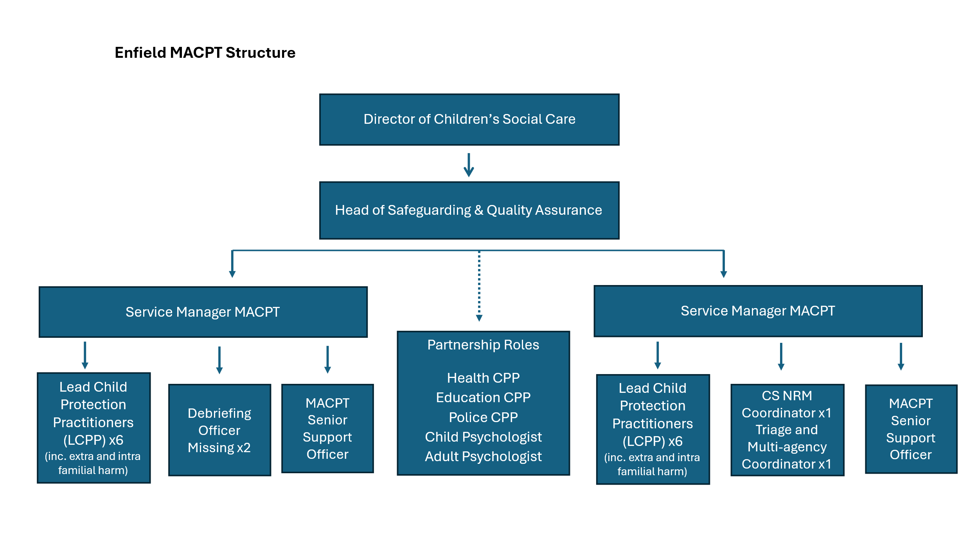
- Number of direct reports:
None, but the postholder will be expected to support the induction and training of colleagues and partners.

- Nature of reporting relationship between post holder and line manager:
Lead Child Protection Practitioners will be directly managed by the MACPT Service Manager. The post holder will receive supervision in line with the local supervision policy and MACPT protocol.

5. Any other relevant statistics:
Not applicable

Key Accountabilities:
- Act on behalf of the local authority in the Multi-Agency Child Protection Team, ensuring any decisions and actions taken are consistent and within the Council's legal responsibilities towards the child. Performing statutory functions as set out in the Children Act 1989 and 2004, and Working Together 2026, specifically regarding child protection as defined under section 47 of the Children Act 1989.
- To chair strategy meetings/discussions, when there is child protection concerns and to keep accurate timely records within liquid logic.
- To lead on the decision making and oversee the child protection investigation (section 47 enquiries) and coordinate child protection medical where the threshold has been met in line with Working Together 2026 and the MACPT protocol, and record outcomes within liquid logic.
- To undertake a minimum of 1 visit with the allocated family help case holding practitioner to the family home or other setting as deemed appropriate during the child protection investigation.
- To ensure child protection processes and plans are implemented in a timely fashion and are robustly monitored.
- To chair child protection conferences (initial and reviews) within statutory timescales and ensuring that the views of children, young people, parents/carers are heard and reflected upon within the decision-making processes. To develop clear, outcome-based child protection plans to secure a child’s future safety and well-being.
- To be the social care technical child protection expert within the MACPT and possess the authority, confidence, and experience to make autonomous decisions in challenging and complex family situations. The post holder will be responsible for producing high-quality reports that reflect their social work expertise and can stand alone as an expert assessment in various forums, including initial child protection conferences and the court arena.
- To act as a social care consultant on child protection to children’s services and partner agencies with the aim of providing direction and guidance to ensure standards are maintained and procedures adhered to.
- To participate in the MACPT duty rota.
- To advocate and apply strength-based approaches within child protection arena to achieve improved outcomes and reduce risk of harm to children.
- To contribute to the MACPT learning and development activities, participating in individual supervision and annual PDR meetings.
- To maintain accurate, detailed and timely case recordings with evidence of decision-making processes and statutory safeguarding actions within the relevant case management systems.
- Follow child protection and safeguarding procedures, alerting respective managers accordingly to any risk issues that may arise including personal safety and safety of others.
- Any other duties reasonably requested by management.
- Carry out all accountabilities in compliance with the Council’s Policies and Procedures.

Key Relationships (Internal and External):

Family help teams across the people department, children’s services colleagues and partner agencies. The post holder will have frequent contact with children, young people and their families who are subject to end-to-end child protection processes. The postholder will work directly alongside the allocated family help lead practitioner.

Equality and Diversity:

The Council has a strong commitment to achieving equality in its service to the community and the employment of people and expects all employees to understand, comply with and promote its policies in their own work.

Health and Safety:

The post holder shall ensure that the duties of the post are undertaken with due regard to the Council’s Health and Safety Policy and to their personal responsibilities under the provisions of the Health and Safety at work Act 1974 and all other relevant subordinate legislation.

For a more detailed definition of these responsibilities, refer to the current versions of the Corporate Health & Safety Policy, Group Safety Policy and employee information leaflet entitled "Health & Safety Policy; Guidance on Staff Health & Safety Responsibilities".

Corporate Health and Safety Responsibilities
All employees have personal responsibilities to take reasonable care for the health and safety of themselves and others. This means:

1. Understanding the hazards in the work they undertake.
2. Following safety rules and procedures.
3. Using work equipment, personal protective equipment, substances, and safety devices correctly; and
4. Working in accordance with the training provided and only undertaking tasks where appropriate training has been received.

Employees shall co-operate with the Council by allowing it to comply with its duties towards them. This requires employees to:

- take part in safety training and risk assessments and suggest ways of reducing risks; and
- take part in emergency evacuation exercises.

Employees shall report all accidents, ‘near miss’ incidents and work related ill health conditions to their manager/supervisor/team leader.

Employees shall read the Corporate Health & Safety – Organisation Part B Policy to ascertain and understand their responsibilities as an employee, line manager, Assistant Director or Director of the Council.

Information Security:

To protect the confidentiality, integrity and availability of Council information, including information provided by customers, partner organisations, and other third parties, where applicable, employees will comply with the Council’s Information Security Policy.

Statement of Commitment to Safeguarding of Children and Vulnerable Adults through safer employment practice:

Enfield Council is committed to safeguarding and promoting the welfare of children and vulnerable adults. Safe recruitment of staff is central to this commitment, and the Council will ensure that its recruitment policies and practices are robust, and that selection procedures prevent unsuitable people from gaining access to children, young people and vulnerable adults. All staff employed to work with or on behalf of children and young people in the Council must be competent.

All staff working with Children & Vulnerable Adults should be aware of and share the commitment to safeguarding and promoting the welfare of children, young people and vulnerable adults when applying for posts at Enfield Council.

PERSON SPECIFICATION

Job Title: Lead Child Protection Practitioner Grade: MM2

Department: Children’s Services: People Department Team: Multi-Agency Child Protection Team (MACPT)

HOW TESTED
Application – A
Test – T
Interview – I
Job Specifics – Skills, Experience, Knowledge & Abilities  Essential:  - Demonstrable recent experience as a manager, advanced practitioner or as an independent reviewing officer.  - Proven recent experience in applying robust safeguarding decision making.  - Experience of coordinating and chairing multi-agency meetings such as strategy meetings, core group meetings, case conferences.  - High level knowledge and applied understanding of social care legislation and guidance both at national and local level.  - Demonstrable ability to work collaboratively with families and the partnership in line with the strength-based model of practice, effectively using recognised approaches including; motivational interviewing, trauma informed practice and relationship-based techniques.  - Strong verbal and written communication skills with the ability to work assertively to achieve sustainable and positive change, utilising negotiation and problem-solving skills in a multi-disciplinary setting. Excellent written skills and the ability to carry out robust assessments, write high-quality reports and evaluate outcomes, keep accurate records, organise, plan and coordinate work.  - Skilled in use of ICT systems e.g. Outlook, MS Office and case management systems.  - Desirable:To have a good understanding of the political structure and role of elected members. | A/T/I
Behaviours  Appropriate behaviours are key to the delivery of our vision for Enfield.  We want staff who will work collaboratively, flexibly and constructively, and exhibit this ethos in all their dealings with residents, colleagues and partners. Our leaders will be exemplars of the following behaviours and encourage them in staff at all levels;  Take Responsibility  We want staff who are willing to make decisions and be accountable for them. Staff should have a positive can-do attitude where they see problems as challenges which can be overcome. They should accept responsibility for service delivery, be clear about their service offer and deliver what they promise.  Open, Honest and Respectful  We want staff who are comfortable and confident to acknowledge the difficulties and the barriers they face. They should also be able to constructively challenge the way things are done where there is evidence that it impedes service delivery. Challenge should be conducted in a professional, courteous manner with the aim of reaching a mutually agreeable resolution.  Listen and Learn  We want staff who are prepared to actively listen and reflect on customer concerns with a view to understanding the customer’s point of view. Staff should be able to receive constructive criticism and be prepared to adapt the way they operate and deliver services where appropriate.  Work Together to find solutions  We want staff who can work collaboratively with other departments and partners, freely sharing their knowledge and skills to identify solutions to address customer concerns.  Candidates: Please ensure you address these behaviours in your responses to the essential (and desirable if applicable) criteria above. | A/I/T
Competencies:

Candidates: Please ensure you address these competencies in your responses to the essential (and desirable if applicable) criteria above.

- Customer focus
- Deliver service performance
- Focus on continuous improvement
- Political awareness and context

Knowledge*
- Knowledge of safeguarding statutory legislation including The Children’s Act 1989 and 2004 and Working Together 2023.
- Knowledge of the guidance and policy at national and local level.
- Knowledge of strength-based models of practice.
- Knowledge of children’s multi-agency safeguarding arrangements

Qualifications & Professional registration criteria  Candidates: Please ensure you address these qualifications in your responses to the essential (and desirable if applicable) criteria, you will be expected to meet these requirements of the role and they will be explored with you at interview.  - Current Social Work England registered children’s social worker  - Degree or equivalent in social work | A
Special requirements  Candidates: Please note you will be expected to meet these requirements of the role and they will be explored with you at interview.  - Enhanced Disclosure Barring Service (DBS) Check  - Flexibility is a requirement to meet the needs of our service users and the business. This may require working reasonable hours outside of normal operating hours to ensure our service users receive the care and support they need. Whilst we operate flexibly, colleagues will likely be required to be office based at least 3 times per week (pro-rata) and this may be increased as needed to meet service needs. Arrangements should be agreed locally with management.  - Colleagues must be able to travel around the Borough and occasionally attend meetings out of Borough. | A

