JOB ROLE PROFILE AND PERSON SPECIFICATION

Post Title and Number: Head of Estates

Present Grade: HOS3

Dept: Environment & Communities

Service/Section/Team: Property Services

Reports to (title): Director of Property

Purpose of the Role:

To act as the Council’s principal advisor on all matters of property management, development, and asset strategy for the operational and commercial property portfolio, ensuring an awareness of property as a strategic and finite resource.

This role will cover all aspects of the council’s considerable property portfolio, Including retail, industrial, office, rural portfolios. All Landlord & Tenant, Valuation, Development Appraisals, Capital Valuation, Business Rates Appeals, custodian of the Corporate Landlord Model and all 120-corporate assets. Advisor to all other council services including but not exclusive to education, adult social care, leisure, green spaces, highways. While the role does not deliver housing, it will be responsible for oversight of residential purposes that require valuation and market advice, up to circa £200m of future purposes.

The role will also be responsible for advising on significant income revenue and receipts at Meridian Water, including the meanwhile money and future strategy for this significant and impactful development (both in terms of finances to the council and the future of that geographic location of our borough).

To continue leading on the transformation of current arrangements to the Council’s adopted Corporate Landlord operating model of centralising the property function with a strategy that is aligned with that of internal services, stakeholders and key partners.

To take a key strategic role in leading on the ‘Right Sizing Programme’ involving the rationalisation of the corporate estate and ensuring that it is modernised and fit to meet the overall operational and service needs of the council, for now, the immediate future and on an evolving basis for the further future.

To lead and manage the commercial and operational property teams in providing innovative strategic property solutions and professional advice ensuring a commercially astute but customer focussed approach.

Review, prioritise and commission the delivery for building repairs, maintenance and compliance on the operational estate.

Carry out annual reviews of the commercial and operational property portfolios for their fitness for purpose, alignment with service strategy and level of use, challenging service and partner occupiers where necessary and recommending underutilised assets for disposal, development or alternative use.

Leading the team on asset management and estate management of the commercial portfolio, optimising the council’s commercial estate (land and building for occupation and investment), the rural portfolio, all working towards corporate objectives, including generating income and supporting the delivery of excellent services.

Leading the team on managing the relevant commercial assets and portfolios, ensuring compliance with legal agreements and minimising exposure to risk.

Be an active member of the wider Enfield Property Services team.

Dimensions including Structure Chart:

- Responsible for the Council’s operational and investment property portfolio with a value of Circa £1bn.
- Responsible for the property investment fund with purchase values between £5m and £25m
- Responsible for JVs with developers and direct developments of up to £30m
- Responsible for income of circa £7.5m per annum across the non-residential portfolio

- Structure Chart:

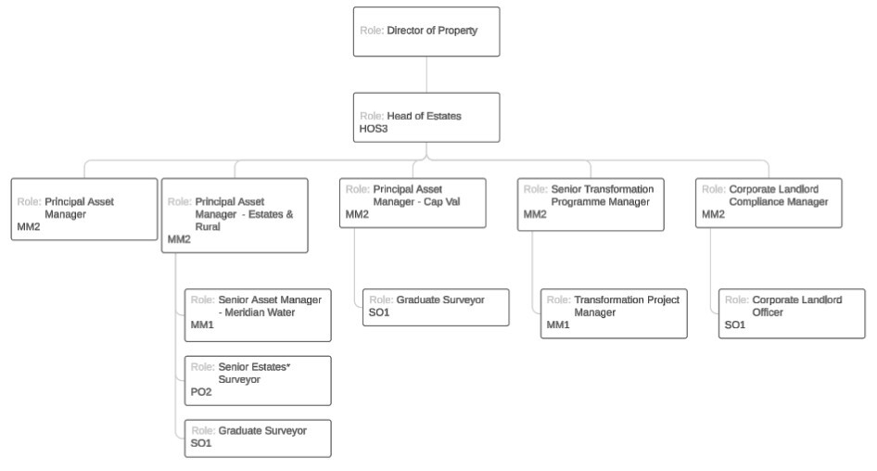

- Direct reports: five in number

- Reports to the Director of Property

Key Accountabilities:

Accountabilities | Anticipated level of  time  H = High  M = Medium  L = low
1. Lead and manage the commercial and operational property teams to meet the objectives of the Strategic Asset Management Plan (SAMP) | H
2. Lead and manage the optimisation of revenue through a proactive asset management process and continued review of options. | H
3. Participate in strategic decision-making concerning the Council’s portfolio of property interests | H
4. Implement and develop further the new Corporate Landlord Policy | H
5. Lead and promote the transformation to Corporate Landlord in collaboration with Council services and partners | H
6. Assist services and partners in their asset management reviews and planning | H
7. Assist in the delivery of annual asset valuations in accordance with  Royal Institute of Chartered Surveyors (RICS) and CIPFA regulations. | M
8. Oversee the Council’s accommodation requirements from a strategic perspective, including space management and utilisation, internal staff moves, and chairing the Council’s ‘Accommodation Board’. | M
9. Lead on the strategic focus of the Right Sizing Programme, including partnership working with services, understanding costs, opportunities for decreasing expenditure, increasing vital revenue and receipts; along with technical work including valuation, landlord and tenant, asset management, disposals and acquisitions. | M
10. Working closely with the Right Sizing team in FM to direct the management of the delivery of the larger capital works required for the programme, retaining responsibility for General Practice Surveying work and delivering smaller capital works required for the programme. | M
11. Oversee action against trespass and intrusions on Council controlled property, including via court proceedings, and to manage gypsy and traveller stop-over and permanent site provision | L
12. Overall estate management for commercial and operational property | M
13. Manage the commercial and operational property teams and external professional advisors | H
14. Provide professional supervision and support for staff involved in (RICS) Assessment of Professional Competence (APC) | L
Accountabilities | Anticipated level of  time  H = High  M = Medium  L = low
15. Develop and monitor KPI’s and where relevant performance frameworks across the commercial and operational property team | M
16. Develop and maintain knowledge through Continual Professional Development and maintain relevant professional memberships | L
17. Provide specialist property development advice to Council departments on capital projects, identify and recommend capital project process improvements. | M
18. Lead on identifying new investment opportunities linked to performance forecasting and property due diligence, identify reinvestment opportunities alongside retained assets to deliver higher yields, ringfence funding from redundant, obsolete or poor performing assets. | M
19. Oversee and arrange for the management of properties held for investment and properties and land held for future development. | M
20. Lead on the execution of UK real estate investment deals from inception to closure working closely with all stakeholders. | M
21. Challenge existing practice, identify and generate innovative proposals for property development in order to deliver corporate objectives and monitor and review the performance of all assets against appropriate benchmarks. | M
22. Provide expert advice on property development and general property advice to the wider Property Services team and the Environment & Communities department. | M
23. Any other duties reasonably requested by management. | L
24. Carry out all accountabilities in compliance with the Council’s Policies and Procedures. | L
25. Deputise for the Director of Property as necessary | L

Key Relationships (Internal and External):

Internal:

Senior Management Team
Service Department leads and key officers
Wider Property Services and FM team
Right Sizing management team
Legal and Finance departments
Council Leader and Councillors

External:

Public agencies in general, the public, businesses and consultants.

Equality and Diversity:

The Council has a strong commitment to achieving equality in its service to the community and the employment of people and expects all employees to understand, comply with and promote its policies in their own work.

Health and Safety:

The post holder shall ensure that the duties of the post are undertaken with due regard to the Council’s Health and Safety Policy and to their personal responsibilities under the provisions of the Health and Safety at work Act 1974 and all other relevant subordinate legislation.

For a more detailed definition of these responsibilities, refer to the current versions of the Corporate Health & Safety Policy, Group Safety Policy and employee information leaflet entitled "Health & Safety Policy; Guidance on Staff Health & Safety Responsibilities".

Corporate Health and Safety Responsibilities
All employees have personal responsibilities to take reasonable care for the health and safety of themselves and others. This means:

- Understanding the hazards in the work they undertake;
- Following safety rules and procedures;
- Using work equipment, personal protective equipment, substances, and safety devices correctly; and
- Working in accordance with the training provided and only undertaking tasks where appropriate training has been received.

Employees shall co-operate with the Council by allowing it to comply with its duties towards them. This requires employees to:

  - take part in safety training and risk assessments and suggest ways of reducing risks; and
  - take part in emergency evacuation exercises.

Employees shall report all accidents, ‘near miss’ incidents and work related ill health conditions to their manager/supervisor/team leader.

Employees shall read the Corporate Health & Safety – Organisation Part B Policy to ascertain and understand their responsibilities as an employee, line manager, Assistant Director or Director of the Council.

Information Security:

In order to protect the confidentiality, integrity and availability of Council information, including information provided by customers, partner organisations, and other third parties, where applicable, employees will comply with the Council’s Information Security Policy.

Statement of Commitment to Safeguarding of Children and Vulnerable Adults through safer employment practice:

Enfield Council is committed to safeguarding and promoting the welfare of children and vulnerable adults. Safe recruitment of staff is central to this commitment, and the Council will ensure that its recruitment policies and practices are robust, and that selection procedures prevent unsuitable people from gaining access to children, young people and vulnerable adults. All staff employed to work with or on behalf of children and young people in the Council must be competent.

All staff working with Children & Vulnerable Adults should be aware of, and share the commitment to safeguarding and promoting the welfare of children, young people and vulnerable adults when applying for posts at Enfield Council.



PERSON SPECIFICATION

Job Title: Head of Estates Grade: HOS3

Department: Environment & Communities Team: Property Services

KNOWLEDGE, SKILLS & ABILITIES | HOW TESTED  Application – A  Test – T  Interview – I
Job Specifics – Skills, Experience, Knowledge, Behaviours  Essential:  - Proven experience to lead, engage, motivate, appraise and develop staff to deliver high standards of service and performance  2. Successfully led teams to respond positively to change  3. Experience of effective budget management and deliver services plans on time and on budget  4. A good understanding of the political structure and role of elected members  5. As a regular and intrinsic part of this role required you to speak to members of the public in English, the ability to  converse at ease, politely and courteously with customers and provide advice in accurate spoken English is essential and  consistent with the requirements of this role.  6. Extensive asset/estate management knowledge and experience in commercial/public sector surveying. This experience should include a variety of General Practice specialisms, for example, Valuation, Landlord and Tenant, Asset Management, Compulsory Purchase, Business Rates, Voluntary Sector etc.  7. Local government and/or private sector experience across a diverse operational/occupational portfolio with demonstrable  experience of advising and presenting to the most senior stakeholders in recent roles.  8. Extensive knowledge, experience and understanding of asset management best practice across a varied portfolio of  mixed assets, high and low level values with varying objectives from the portfolios.  9. Experience managing staff as well as external providers of professional services within an asset management/estate management team  - Strategic thinker with excellent judgement and an ability to work effectively across professional disciplines within the built environment. Experience in developing and delivering strategies with proven successful deliverables.  - Good working knowledge of IT systems, including MS Office, asset management programmes, data bases, budgeting, and other relevant software packages.  - Detailed understanding of all relevant legislation relation to operational and occupational property  13. Sound commercial and financial acumen with experience in managing, planning and monitoring significant budgets.  Desirable:  1. Understanding of the Corporate Landlord approach to asset management  2. Experience of working with and winning over a large and diverse stakeholder community  3. Experience of developing a significant change programme | A/I  A/I  A/I  A/I  A/I  A/I  A/I  A/I  A/I  A/I  A/I  A/I  A/I  A/I  A/I  A/I
Behaviours  Appropriate behaviours are key to the delivery of our vision for Enfield.  We want staff who will work collaboratively, flexibly and constructively, and exhibit this ethos in all their dealings with residents, colleagues and partners. Our leaders will be exemplars of the following behaviours and encourage them in staff at all levels.  Takes Responsibility  We want staff who are willing to make decisions and be accountable for them. Staff should have a positive can-do attitude where they see problems as challenges which can be overcome. They should accept responsibility for service delivery, be clear about their service offer and deliver what they promise.  Is Open, Honest and Respectful  We want staff who are comfortable and confident to acknowledge the difficulties and the barriers they face. They should also be able to constructively challenge the way things are done where there is evidence that it impedes service delivery. Challenge should be conducted in a professional, courteous manner with the aim of reaching a mutually agreeable resolution.  Actively Listening and Learning  We want staff who are prepared to actively listen and reflect on customer concerns with a view to understanding the customer’s point of view. Staff should be able to receive constructive criticism and be prepared to adapt the way they operate and deliver services where appropriate.  Working Together to find solutions  We want staff who can work collaboratively with other departments and partners, freely sharing their knowledge and skills to identify solutions to address customer concerns.  Candidates: Please ensure you address these behaviours in your responses to the essential and desirable (if applicable) criteria above. | A/I
Competencies:  Candidates: Please ensure you address these competencies in your responses to the essential and desirable (if applicable criteria above).  - Customer focus  - Deliver service performance  - Focus on continuous improvement  - Political awareness and context | A/I
Qualifications & Professional registration criteria  Candidates: Please ensure you address these qualifications in your responses to the essential criteria, you will be expected to meet these requirements of the role and they will be explored with you at interview.  1. Member or Fellow of the Royal Institution of Chartered Surveyors or relevant equivalent experience. Other desirable qualifications include IRRV, Prince 2, Accredited Mediator, Registered Valuer, MCIArb (or equivalent within those fields) | A/I
Special requirements  Candidates: Please note you will be expected to meet these requirements of the role and they will be explored with you at interview.  - Hold a clean driving licence and have access to a vehicle to make site visits, or you will need to put in place suitable alternative travel arrangements to land and buildings (e.g. bicycle). | A/I

