JOB ROLE PROFILE AND PERSON SPECIFICATION

Post Title and Number: Data Science and Technical Lead

Present Grade: PO1 Dept: People

Service/Section/Team: People Department, Public Health

Reports to (title): Business and Data Intelligence Manager, People Department

Purpose of the Role:

You will be based in the Business and Data Intelligence team in the People Department and provide services across the People Department data teams (Children Social Care, Adult Social Care, Prevention & Community Safety, Education, and Public Health teams) and Digital Services and external system providers. The Data and Technical Lead will find, extract, transform and interpret People department data sources, including managing big data systems, the data sciences and merging data ensuring consistency of the data-sets in the systems such as social care and NHS systems, and create visualisation reports based on Python, SQL, Power BI, Power Automate, Robotic Automation, Tableau, Excel, VBA, and Metabase etc enabling services users to understand the status, trends and predictions in business operations and strategy. You will build models and tools to join data from discrete systems and integrate for further combined analytics, using statistical methods in machine learning and modelling. You will be the first point of contact for technical enquiries relating to business and data intelligence systems.

You will work with the Business and Data Intelligence Manager to understand business requirements and intelligence reporting specifications, design and implement efficient data models, pipelines and platforms, guide and communicate with the Head of Data & Intelligence and Digital Services to enhance the business intelligence reporting function, to build automation strategies and changes. You will also work with performance and reporting systems, tools, and colleagues confidently and effectively to extract, analyse, and report on key statutory, performance, and outcomes data.

Dimensions including Structure Chart:

- Annual budgetary amounts with which the role is either directly or indirectly concerned:

The Data and Tech Lead will be directly and indirectly involved in strategic projects across the People department over £200,000.

- Structure Chart:

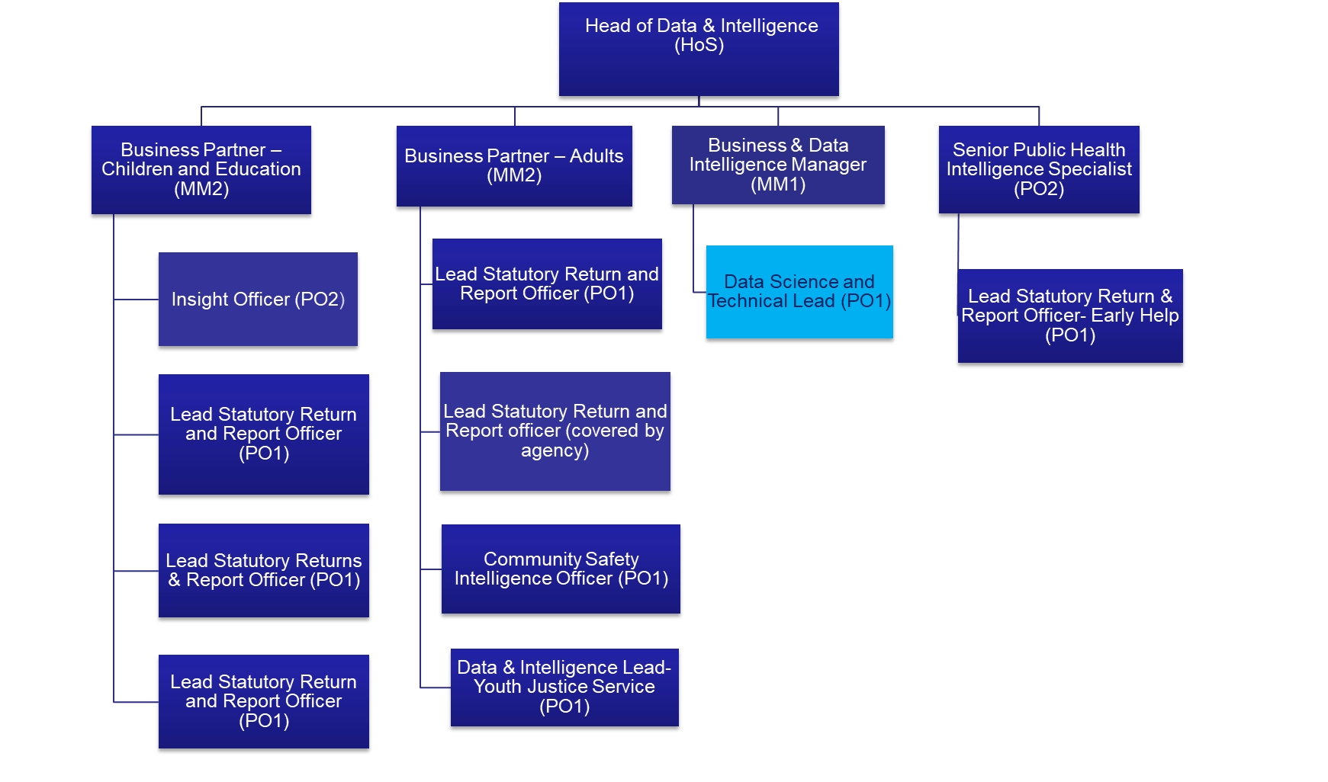

- Number of direct reports: None

- Nature of reporting relationship between post holder and line manager: The Data and Technical Lead will be expected to carry out tasks assigned to them independently, but with the support and oversight of their line manager. Regular one to ones will take place with the line manager and clear objectives will be set annually and reviewed 6-monthly through the Council’s PDR process.

Key Accountabilities:

As the Data and Technical Lead within the People Department in the Enfield Council you will:

- Collaborate with service leads and report developers to define data requirements and reporting specifications, design and implement efficient reporting models, pipelines and platforms to drive business decisions using tools such as Power BI, Power Automate, Business Objects, Python and SQL across the people department, and maintain department-wide consistency in all service platforms
- Develop systems architectures, introduce best practices, and ensure standardisation to support prudent data integration using data science and machine learning tools such as Python to make report development efficient and automate. This includes customisation in statutory reporting, performance dashboards, and operational intelligence for Children Social care (CSC), Adult Social Care (ASC), Prevention & Community Safety (PCS), Education Services (ES), and Public Health (PH) and support statutory returns and weekly/monthly performance reports.
- Assist report development and project delivery, act as a single point of contact in supporting the developers for smooth technical and project management
- Build and manage algorithms, develop machine learning and statistical models to analyze and interpret data, extract and manage data, and merge, manage, and extract data from various large data sources for reporting and analysis.
- Interpret and communicate insights: Clearly explain complex data findings to both technical and non-technical colleagues.
- Ensure data quality, consistency, and compliance with governance standards. Responsible for ensuring systems are technically sound and aligned with service needs. Lead accessing the systems' fit for purpose status, and collaborate constructively with Digital Services for necessary updates, upgrades, and monitor coordinated maintenance of reporting platforms and diverse data systems, liaise with external system providers to troubleshoot, enhance, and future-proof platforms.
- Be the first point of contact for technical enquiries relating to data & intelligence systems.
- Identify opportunities for system integration and process improvement to enhance service delivery. Act as the technical representative in meetings with Digital Services, suppliers, and system vendors in collaboration with Data & Intelligence Management.
- Embrace new contemporary knowledge, stay abreast of digital trends, including AI and automation, and recommend innovative solutions and learning in technology and systems in the business and data Intelligence framework.
- Provide technical guidance and support staff to absorb knowledge, data literacy and intelligence functions across the people department staff and business partners.
- Work closely with the Business and Data Intelligence Manager to align technical delivery with strategic goals and support cross-departmental initiatives and contribute to the wider data culture within the Council.
- Excellent verbal and written communicator with excellent inter-personal skills.

Accountabilities | Anticipated level of time
Technical leader for providing expert support on data architecture, integration, ensure consistency of data-sets and reporting platforms, including Python, SQL (SSRS, SSMS), Tableau, Excel (with Macro/VBA), Power BI, Power Automate, and Business Objects and responsible for development and maintenance of People Department data application systems, including Liquidlogic, Eclipse/ CareFirst, Synergy and Youth Justice Systems (CVYJ) and other relevant systems. | H
Build and manage mathematical models and algorithms: Develop machine learning and statistical models to analyse and interpret data.  Extract and manage data: Merge, manage, and extract data from various sources for reporting and analysis.  Interpret and communicate insights: Clearly explain complex data findings to both technical and non-technical colleagues. | H
Assist development, maintenance, and production of statutory reports, performance reports, management insights and project management. Be the first point of contact for technical enquiries relating to data & intelligence systems. | H
Identify and escalate any budget and technical risks. Collaborate and liaise with Digital Service to maintain the above-stated data & intelligence platforms as efficient, reliable, and sustainable. Coordinate system upgrades and transformations where necessary and serve as the primary point of contact for technical inquiries related to data & intelligence systems. | H
With Business and Data Intelligence manager, tactically improve the data and intelligence architecture and support developers and business users to solve complex business problems, leading to effective functioning of the wider business function across the people department, finding technical solutions for non-technical problems and facilitate to the implementation | H
Support Children Social care, Adult Social Care, Prevention & Community Safety, Education, and Public Health data teams and their business requirements | H
Support development of Pentana related work. | L
Liaise with Digital Services to improve the performance of systems. | M
Keep up to date with relevant legislation and national and regional database and system developments that impact the council and contribute toward the effective production of the statutory returns—excellent understanding of data protection, governance and respecting data, including GDPR. | M
Support project management tasks, process invoices and complete other administrative tasks as required. | L
Excellent verbal and written communication with excellent inter-personal skills. | H
Any other duties reasonably requested by management. | L
Carry out all accountabilities in compliance with the Council’s Policies and Procedures. | L

Key Relationships (Internal and External):

The Data and Teach Leac will be expected to have close working relationships with all members of their respective departments and will also need to develop effective working relationships with officers across the People Department involved in the production of statutory and performance data and reporting. They will also have relationships with external stakeholders and partners such as system suppliers and data linkage projects. This will include, but is not limited to, other council departments; the Integrated Care Board and NHS Trusts; Metropolitan Police; grant making authorities and agencies, external consultancies and think tanks, peer local authorities (to investigate their systems and to find solutions); Central Government Departments.

Equality and Diversity:

The Council has a strong commitment to achieving equality in its service to the community and the employment of people and expects all employees to understand, comply with and promote its policies in their own work.

Health and Safety:

The post holder shall ensure that the duties of the post are undertaken with due regard to the Council’s Health and Safety Policy and to their personal responsibilities under the provisions of the Health and Safety at work Act 1974 and all other relevant subordinate legislation.

For a more detailed definition of these responsibilities, refer to the current versions of the Corporate Health & Safety Policy, Group Safety Policy and employee information leaflet entitled "Health & Safety Policy; Guidance on Staff Health & Safety Responsibilities".

Corporate Health and Safety Responsibilities
All employees have personal responsibilities to take reasonable care for the health and safety of themselves and others. This means:

1. Understanding the hazards in the work they undertake.
2. Following safety rules and procedures.
3. Using work equipment, personal protective equipment, substances, and safety devices correctly; and
4. Working in accordance with the training provided and only undertaking tasks where appropriate training has been received.

Employees shall co-operate with the Council by allowing it to comply with its duties towards them. This requires employees to:

- take part in safety training and risk assessments and suggest ways of reducing risks; and
- take part in emergency evacuation exercises.

Employees shall report all accidents, ‘near miss’ incidents and work-related ill health conditions to their manager/supervisor/team leader.

Employees shall read the Corporate Health & Safety – Organisation Part B Policy to ascertain and understand their responsibilities as an employee, line manager, Assistant Director or Director of the Council.

Information Security:

To protect confidentiality, integrity and availability of Council information, including information provided by customers, partner organisations, and other third parties, where applicable, employees will comply with the Council’s Information Security Policy.

Statement of Commitment to Safeguarding of Children and Vulnerable Adults through safer employment practice:

Enfield Council is committed to safeguarding and promoting the welfare of children and vulnerable adults. Safe recruitment of staff is central to this commitment, and the Council will ensure that its recruitment policies and practices are robust, and that selection procedures prevent unsuitable people from gaining access to children, young people and vulnerable adults. All staff employed to work with or on behalf of children and young people in the Council must be competent.

All staff working with Children & Vulnerable Adults should be aware of and share the commitment to safeguarding and promoting the welfare of children, young people and vulnerable adults when applying for posts at Enfield Council.

PERSON SPECIFICATION

Job Title: Data Science &Technical Lead- Data& Intelligence Grade: PO1

Department: People Department Team: Data & intelligence team, Public Health

HOW TESTED
Application – A
Test – T
Interview – I
Job Specifics – Skills, Experience, Knowledge & Abilities  Essential:  - Proven experience in leading and developing big data systems and projects within a public sector or complex organisational environment.  - Strong understanding of data sciences, statistical modelling, data architecture, data integration, and reporting platforms, including Python, SQL (SSRS, SSMS), Tableau, Excel (with Macro/VBA), Power BI, Power Automate, and Business Objects  - Advanced technical skills in data modelling, data validation, ETL processes, dashboard/report development and project management. Strong problem-solving and analytical skills.  - Demonstrated ability to translate business needs into technical solutions, proactive and solution-focused high-quality performance, and a continuous improvement mindset.  - Ability to lead technical projects and manage competing priorities, high attention to detail and commitment to data quality.  - Understanding of contemporary developments and concerns affecting government data systems such as Big Data, Artificial Intelligence, Information Security, Business Continuity and GDPR  - Ability to work collaboratively across IT teams, service teams, departments, including and external system providers and partner organisations. Excellent communication skills, able to explain complex technical concepts to non-technical stakeholders.  - Skilled in mentoring and supporting junior technical staff. Ability to engage, coach, knowledge transfer and motivate the data teams and upskill the team members  - Degree or equivalent qualification in Computer Science, Data Science, Information Systems, or a related field.  Adaptable and open to innovation and change. Strong sense of accountability and ownership.Excellent verbal and written communication with excellent inter-personal skills.  Desirable:  - Prior experience in Liquidlogic, Synergy, CareFirst/ Eclipse, Youth justice information systems and public health intelligence data systems  - Relevant certifications in data platforms (e.g. Microsoft Power BI, SQL Server, Azure) are desirable. | A/I  A/I  A/I  A/I  A/I  A/I  I  I  A  IA/I  A/I  A
Behaviours  Appropriate behaviours are key to the delivery of our vision for Enfield.  We want staff who will work collaboratively, flexibly and constructively, and exhibit this ethos in all their dealings with residents, colleagues and partners. Our leaders will be exemplars of the following behaviours and encourage them in staff at all levels.  Take Responsibility  We want staff who are willing to make decisions and be accountable for them. Staff should have a positive can-do attitude where they see problems as challenges which can be overcome. They should accept responsibility for service delivery, be clear about their service offer and deliver what they promise.  Open, Honest and Respectful  We want staff who are comfortable and confident to acknowledge the difficulties and the barriers they face. They should also be able to constructively challenge the way things are done where there is evidence that it impedes service delivery. Challenge should be conducted in a professional, courteous manner with the aim of reaching a mutually agreeable resolution.  Listen and Learn  We want staff who are prepared to actively listen and reflect on customer concerns with a view to understanding the customer’s point of view. Staff should be able to receive constructive criticism and be prepared to adapt the way they operate and deliver services where appropriate.  Work Together to find solutions  We want staff who can work collaboratively with other departments and partners, freely sharing their knowledge and skills to identify solutions to address customer concerns.  Candidates: Please ensure you address these behaviours in your responses to the essential (and desirable if applicable) criteria above. | A/I
Competencies:  Candidates: Please ensure you address these competencies in your responses to the essential (and desirable if applicable) criteria above.  1. Customer focus  2. Deliver service performance  3. Focus on continuous improvement  4. Political awareness and context | A/I

