

Be Bold, Make a Difference, Show you Care

JOB ROLE PROFILE AND PERSON SPECIFICATION

Post Title and Number: Business Analyst

Present Grade: P02

Department: Resources / Revenues and Transactional Services

Reports to: Head of Business Insight & Performance Reporting

Purpose of the Role:

- The Business Analyst is part of a multi-disciplinary department responsible for capturing, developing and delivering user requirements. The role will have responsibility for enabling Digital Service changes, defining needs and recommending solutions that will deliver value for council departments.

- Working in close collaboration with other Digital Services colleagues, such as Project Managers, Change Managers, Technical Architects, Systems and Server Engineers, and Application Integration Engineers, to ensure options for new digital work are viable and feasible

- To undertake extensive data analysis to support decision-making and identify trends.

- To engage and work with senior managers, colleagues in the business areas and other teams across council departments to support and develop clear business digital, data and technology solutions to deliver the Digital Services portfolio of projects.

- Lead the mapping and designing of new processes, developing and delivering user research, customer journeys, resource requirements, design technology requirements, workflows and information flows, creating a detailed library of documentation of the current ways of working as well as the proposed new ways.

- To act as the first point of contact for business areas to liaise with Digital Services to understand new technologies and opportunities in their field, to discuss current demands and pressures on their services and to work collaboratively to develop solutions.

- To develop a robust understanding of business-critical systems, linked ot the business area they support, to use this knowledge when developing options for business efficiencies and/or increased income and savings opportunities.

- To work closely with the Project managers and Change managers to ensure essential and desirable requirements, approved at the planning stage, are tracked and robustly delivered in the new digital capability.

- Working closely with key stakeholders to define opportunities and identify priorities against several competing activities, at times with demanding deadlines on an ongoing basis. This includes the consideration of Artificial Intelligence, Robotic Process Automation (RPA) and extended use of the applications within the Microsoft Office 365 licence to optimise opportunities at relatively low cost.

- To undertake proportionate discovery work for ideas received from the business through the Ideas Process. Delivering an initial assessment of the work, e.g., time, budget, resources, impacts, risks that can be assessed and inform the future pipeline of work, depending on the size and scale of the work.

- To undertake robust investment appraisals, working closely with colleagues in Digital Services, business areas, finance, and procurement to understand the total cost of the digital transformation work to determine the cost/value analysis

Dimensions including structure chart:

- Annual budgetary amounts with which the role is either directly or indirectly concerned: This will vary depending on the Digital Services priorities and responsibilities of the role as this evolves.

- Structure Chart:

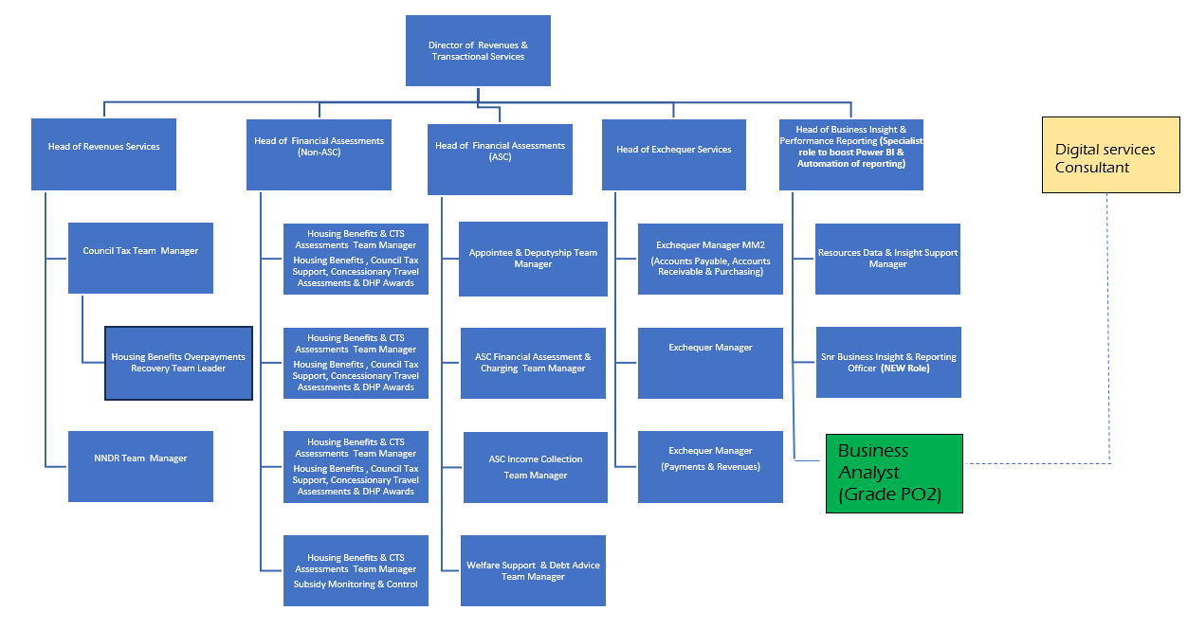

- Number of direct reports: No direct reports. Leading and managing as part of project teams as required

- Nature of reporting relationship between post holder and line manager. Reports to the Business Adoption Manager

- Any other relevant statistics. See Purpose of the Role and Key Accountabilities sections for details.

Key accountabilities:

Accountabilities
Business analysis | - Leading the business analysis capability for projects within the Digital Services portfolio, ensuring all requirements have been documented, impacts to the business have been fully understood and documented, data analysis has been undertaken to agree the baseline data, and digital solutions have been successfully assessed against the requirements to ensure the new capability meets the needs and expectations of the business.  - Working with the assigned Change Manager and Project Manager for projects in the Digital Services portfolio to ensure the business areas are fully supported to understand the options for project delivery  - Working with business areas to develop capabilities for Artificial Intelligence, Robotic Process Automation (RPA) and extended use of the applications within the Microsoft Office 365 licence so that smaller improvements within the service can be managed without the need for Digital Services projects.  - Investigating, analysing, articulating and solving complex problems leading to new and changing business requirements and opportunities for improvement.  - Planning the business analysis approach, governance & information management.  - Identifying new digital, data and technology solutions and their application for the benefit of the council and users.  - Developing business cases for digital, data and technology transformational change, including options and recommending a way forward, enabling the council to select appropriate projects to progress.  - Shaping and handing over well-defined projects (including scope and governance) to Digital Services project managers and their delivery teams.
Requirements definition and management | - Developing in-depth business and user requirements.  - Working with the team and key stakeholders to agree priorities and to agree the pipeline of initiatives and projects, for both business areas and Digital Services  - Specifying requirements from both business and user perspectives to enable agreed changes to be implemented and delivered effectively.
Business improvement process | - Coordinating the analysis, identification, prioritisation and implementation of improvements and efficiencies.  - Identifying and exploring opportunities for service and business improvement.  - Championing the potential for automation of processes, determining costs and benefits of new approaches.  - Assisting the team in managing change and implementing change as required.
Stakeholder relationship management | - Work collaboratively with services, staff and managers to develop workable and innovative solutions to complex business problems as a means of increasing efficiency, improving the delivery of services to customers and delivering tangible benefits to the customer and organisation.  - To act as the first point of contact for business areas to liaise with Digital Services to understand new technologies and opportunities in their field, to discuss current demands and pressures on their services and to work collaboratively to develop solutions.  - Identifying, analysing, managing and monitoring relationships with and between stakeholders.  - Communicating with stakeholders clearly and regularly, clarifying mutual needs and commitments through consultation and consideration of impacts whilst focusing on user needs.  - Facilitating workshops with stakeholders, managing customer and supplier relationships, and ensuring that recommendations deliver maximum benefit for the council.

Any other duties reasonably requested by management.
Carry out all accountabilities in compliance with the Council’s Policies and Procedures.

Key relationships (Internal and External):

- Digital Services Senior Management Team (SMT).
- Stakeholders at all levels of the Council, including Executive Directors, Directors, and Heads of Service across the organisation.
- Partner organisations (including other local authorities, public sector organisations and external consultants).
- Suppliers

Equality and Diversity:

The Council has a strong commitment to achieving equality in its service to the community and the employment of people and expects all employees to understand, comply with and promote its policies in their own work.

Health and Safety:

The post holder shall ensure that the duties of the post are undertaken with due regard to the Council’s Health and Safety Policy and to their personal responsibilities under the provisions of the Health and Safety at Work Act 1974 and all other relevant subordinate legislation.

For a more detailed definition of these responsibilities, refer to the current versions of the Corporate Health and Safety Policy, Group Safety Policy and employee information leaflet entitled "Health and Safety Policy; Guidance on Staff Health and Safety Responsibilities".

Corporate Health and Safety Responsibilities
All employees have personal responsibilities to take reasonable care for the health and safety of themselves and others. This means:

1. Understanding the hazards in the work they undertake.
2. Following safety rules and procedures.
3. Using work equipment, personal protective equipment, substances, and safety devices correctly; and
4. Working in accordance with the training provided and only undertaking tasks where appropriate training has been received.

Employees shall co-operate with the Council by allowing it to comply with its duties towards them. This requires employees to:

- take part in safety training and risk assessments and suggest ways of reducing risks; and
- take part in emergency evacuation exercises.

Employees shall report all accidents, ‘near misses’ incidents and work-related ill health conditions to their manager/supervisor/team leader.

Employees shall read the Corporate Health and Safety – Organisation Part B Policy to ascertain and understand their responsibilities as an employee, line manager, Assistant Director or Director of the Council.

Information Security:

To protect confidentiality, integrity and availability of Council information, including information provided by customers, partner organisations, and other third parties, where applicable, employees will follow the Council’s Information Security Policy.

Statement of Commitment to Safeguarding of Children and Vulnerable Adults through safer employment practice:

Enfield Council is committed to safeguarding and promoting the welfare of children and vulnerable adults. Safe recruitment of staff is central to this commitment, and the Council will ensure that its recruitment policies and practices are robust, and that selection procedures prevent unsuitable people from gaining access to children, young people and vulnerable adults. All staff employed to work with or on behalf of children and young people in the Council must be competent.

All staff working with Children and Vulnerable Adults should be aware of and share the commitment to safeguarding and promoting the welfare of children, young people and vulnerable adults when applying for posts at Enfield Council.

PERSON SPECIFICATION
Job Title: Business Analyst Grade:PO2
Department: Resources / Revenues and Transactional Services Team: Revenues and Transactional Services

KNOWLEDGE, SKILLS & ABILITIES | HOW TESTED  Application – A  Test - T  Interview – I

Job Specifics – Skills, Experience and Competencies

Knowledge*  - Job Specifics – Skills, Experience and Competencies  Essential:  - Demonstrable experience of working as a Business Analyst or User Researcher.  - Demonstrable experience of high-quality stakeholder management across a range of roles, e.g., Senior Management, business areas, communications and suppliers, recognising the different approaches and responses from stakeholders when working in a change management environment.  - Demonstrable knowledge and experience of working in a project management environment, ensuring that work is completed to the expected quality and within time and cost.  - Experience of gathering and writing business and user requirements, including process mapping, user journeys, and wireframes to articulate and solve complex problems.  - Proficient in techniques for ensuring that full account is taken of customers’ real and stated needs in the delivery of products and services, and skilled at separating essential from desirable requirements  - Demonstrable experience of undertaking financial investment appraisals to assess the total costs of delivery and provide cost/benefits analysis  - An understanding of the key information requirements and underlying infrastructure requirements needed to enable Digital Services to deliver effective, value-for-money, customer-focused business solutions to the Council, that deliver efficiencies and effective new ways of working and create opportunities for additional income and/or savings  - Good understanding of Lean Systems Thinking and process review, and the ability to deliver effective digital, data and technology outcomes for organisations and users.  - Able to interact directly with senior stakeholders, facilitating and bringing the right people together to bring about digital, data and technology change.  - Understands users and can identify who they are and what their needs are based on evidence, and can translate user stories and propose design approaches or services to meet their needs.  - Ability to capitalise on new and emerging technologies for Artificial Intelligence, Robotic Process Automation (RPA) and extended use of the applications within the Microsoft Office 365 licence, whether as an existing capability or a willingness to learn new skills.  - Excellent communication skills, both orally and in writing, to produce reports and project planning documents and to contribute to and influence project meetings  - Good English literacy (written and verbal) and numeracy skills.  - Self-confident and articulate, able to influence others to deliver results and deliver at pace – focusing on delivering timely performance with energy and taking responsibility and accountability for quality outcomes.Ability to work across a range of business areas simultaneously.  Desirable:  - Experience using MS Project and Visio  - Experience of working in or delivering digital, data and technology transformation in local government or large multi-layered service organisation, the ability to deliver change, bring new insights and implement best practice.  - Qualification or equivalent experience in a relevant formal project management methodology (e.g. Prince 2, Agile or Scrum Master) to foundation stage or above.  - Specialist qualification(s) in Business Analysis, e.g., relevant certifications such as CBAP, CCBA, or similar  - Formal training or experience in business analysis and/or system thinking processes and approaches | A/I  A/I  A/I  A/I  A/I  A/I  A/I  A/I
Competencies  Leading change  Build relationships  Creating innovation  Communicate and Influence  Deliver Results  Provide Leadership/Customer focus  Giving support | A/I
Qualification(s)*

Desirable:
- Formally trained or experienced in Business Analysis, User Research, Systems Thinking or Lean techniques and practices.

Other Special Requirements*

- Availability to work out of hours, including weekends
- Availability to provide on-call service

